HSO201 Research Paper

**Socio-Economic Impacts of Covid-19**

Submitted By:-

Aadeesh Jain Kushal Maheshwari

Aanchal Jain Palak Khandelwal

Deepak Adarsh Shivanshu Tyagi

Devansh Jain Tanishka Agrawal

Janhavi Bhoge Yatish Goel

**TABLE OF CONTENTS**

**INTRODUCTION** **3**

Purpose of Study 3

Background Information 3

Significance and Motivation 4

**RESEARCH OBJECTIVES** **6**

**SOME REMARKS ON POLLUTION IN INDIAN CITIES AND ECONOMIC DEVELOPMENT OF INDIA** **8**

**LITERATURE REVIEW** **12**

**METHODOLOGY** **15**

OLS 15

Panel Analysis 16

– Fixed effects 16

– Random effects 17

Model 1: Without polynomial terms 17

Model 2: With polynomial terms 18

**DATA DESCRIPTION** **19**

Economic Activity 19

Air Quality 21

**HYPOTHESIS** **23**

**RESULTS** **26**

**CONCLUSION** **29**

**REFERENCES** **30**

**APPENDIX** **31**

Box Plot 31

Problem Statements 32

Problem statement (Definitions and a Brief Overview) - Mobility Index 32

Problem statement (definitions and a Brief Overview ) - AQI 32

# INTRODUCTION

## **Purpose of Study**

The Coronavirus pandemic disrupted economic activity all over the world. This disease emerged in China and spread globally. This is the third time in the past two decades that a novel virus has led to a pandemic condition. The primary concern for COVID-19 includes its significant number of deaths, infections, mortality, and its effect on specific age groups.

Pandemics are expected to have, at least in the short run, a drastic negative impact on economic activities. However, as many countries observe social distancing and self-quarantine, the reduced human interference in the natural environment has given nature a “healing time.” The major impact of lockdown due to COVID-19 can be observed on air quality, which everyone has experienced and recorded in various official reports. We also aim to analyze the impact of covid on mobility with the help of the cumulative number of cases, deaths, recoveries due to covid, relating them to their normal day-to-day activities. Outcomes of this analysis give the policymakers an idea to define the Post-Covid strategy for our country and provide some useful insights into the drastic effects on our economy.

## Background Information

The first pneumonia case was discovered on December 8, 2019, in a wet market in Wuhan, the capital city of Hubei Province of China. Several clusters of patients with such pneumonia were reported afterward, throughout late December 2019. Both cases and deaths started rising from March 2020. As of 23 June, total cumulative cases were over 9.2 million, while there were over 470,000 deaths across the World. China experienced the first wave of cases in February 2020, after which it has been able to control the spread. India experienced its first wave till September 2020 and crossed its peak in mid-September with 11.12 lakh active cases on 17th September 2020 and 97,860 daily new cases on 16th September 2020. After which, it has been able to effectively manage the spread – avoiding the second wave till now but unfortunately, the situation deteriorated, and now in April 2021, India is suffering from the second wave of Coronavirus with about 3.52 lakhs new daily cases.

On 25 March 2020, India imposed a stringent lockdown on its 1.3 billion people, locking them in their homes initially for 21 days which eventually got extended for over two months. It was followed by gradual unlocking and phasing out of the containment measures. This caused a decline in manufacturing activities, reducing carbon emissions. PM10 and PM2.5 concentrations reduced by about half in comparison to the pre-lockdown period.

Carbon monoxide and nitrogen dioxide contents in the air have also shown a noteworthy decline during the lockdown. This reduction can be attributed to the fall in vehicular emissions as a result of the lockdown. Using computer models for comparison, NASA researchers found that since February 2020, pandemic restrictions have reduced global nitrogen dioxide concentrations by nearly 20%. The results were presented at the 2020 International Conference for High-Performance Computing, Networking, Storage, and Analysis.

## **Significance and Motivation**

According to the latest Situation Update Report -65 (28 April 2021) by WHO, India reports the highest number of daily cases in the world, with almost 50% of new cases reported in the world. Among Indian states, Maharashtra is still leading the tally with the highest number of cases (more than 4 million), followed by Delhi, Kerala, Karnataka, Uttar Pradesh, and Tamil Nadu (all more than 1 million). India is also reporting the fourth-highest number of deaths globally; the current case fatality ratio (CFR) is 1.12%. With such an alarming situation, the significance of using statistics and coming up with conclusions supported by results increases significantly.

Some of the significant decisions taken by various governments to control coronavirus’s spread included social restrictions or mobility restrictions policy that affected economic activity. These policies led to a decline in economic activities whose severity depends on the stringency and duration of these policies. In the pandemic era, GDP statistics become more critical to evaluate economic activity, and around the world, more attention is being paid to these statistics. These statistics give the signal to economists that the recession period is approaching. Mobility data are more dynamic, available at a daily rate, and can be used to measure the effect of social distancing on other aspects. Economic activity has been seriously affected by reduced mobility, owing to official restrictions and private decisions; uncertainty regarding the post-pandemic economic prospects and policies has impacted investment. This became the motivating factor for us to find and relate the socio-economic impacts of covid.

Since the COVID-19 pandemic began, space- and ground-based observations have shown that Earth’s atmosphere has seen significant reductions in some air pollutants. However, we wanted to know how much of that decline can be attributed to changes in human activity during pandemic-related shutdowns. These positive results motivated us to look at the only good side of covid.

# **RESEARCH OBJECTIVES**

The main objective of this paper is to analyze the impact of COVID-19 on Economic activities using Google Community Mobility data as a proxy. Further, analysis on Air Quality during pandemic for sample cities of India has been done considering impact of lockdown along with other indicators .

Using Google Community Mobility data, a proxy for economic activities, we aim to analyze the impact of Lockdown using it’s stringency Index, covid cases, recoveries and deaths over Google mobility parameters.

For analysis on Air Quality, we aim to study the impacts of lockdown indicated by dummy variables and other weather variables, including temperature, wind speed, humidity, on the Air Quality of different cities with the help of a Panel fixed and random regression model.

This paper also reviews the literature on the effectiveness of lockdown measures (stringency measures) and their relation with the pollution index. Summarizes their methodology, results and ending with a conclusion.

**Assumptions**

Social and mobility restrictions affect economic activity. These restrictions affect differently towards the country's economic activities and declining GDP since it depends on the severity and duration of the lockdown. We are assuming that the results we obtain would vary from country to country and can’t be generalized.

**A high-developed region provides a wide range of mobility, and the higher mobility individual diversification drives to higher economic opportunity, which leads to higher socio-economic development.**

Mobility regulations are different from total lockdown, which require all industries to close except the essential ones, such as health and groceries. Under social and mobility restrictions, the industries can still run their activity with new procedures**.** Based onthe above two facts, we assume that a high-developed region would be affected more severely due to mobility restrictions as compared to backward less developed regions .

The effect of mobility on economic output depends on the economic structure and the industry contribution to GDP. For instance, countries that rely on labor-intensive industries requiring high people mobility may have a greater impact by social restriction. In addition, the country’s formal and informal workers' composition will also determine the degree of the effect of mobility. On one hand, formal sectors can still produce output with lesser mobility, such as working from home while On the other hand, some jobs may require movement and hard to be done remotely and affected to a greater extent .

All these suppostions and assumptions show that Human mobility has a significant association with social interaction and economic development. Going forward, social distancing and its measurements will continue to play a key role in academic research and policy development.

# SOMEREMARKSONPOLLUTIONININDIANCITIESANDECONOMICDEVELOPMENTOFINDIA

As the COVID19 was spreading, several countries started putting restrictions to contain the spread. The stringency index estimates the strictness of these restrictions. As the number of cases rose, the stringency was increased to limit the number of infections. In figure 1, we plot a non-parametric kernel regression function connecting cumulative cases with lockdown stringency. We see a peak around a stringency of 80. As the Lockdown came into being, it forced people to remain at home and several activities were restricted. We use Google’s Mobility Index to capture the movement trend and relate it with economic activities. In figure 2, we plot the 6 variables of Mobility index against days. We clearly see a declining trend in all indexes as the lockdown began, except for the residential mobility.

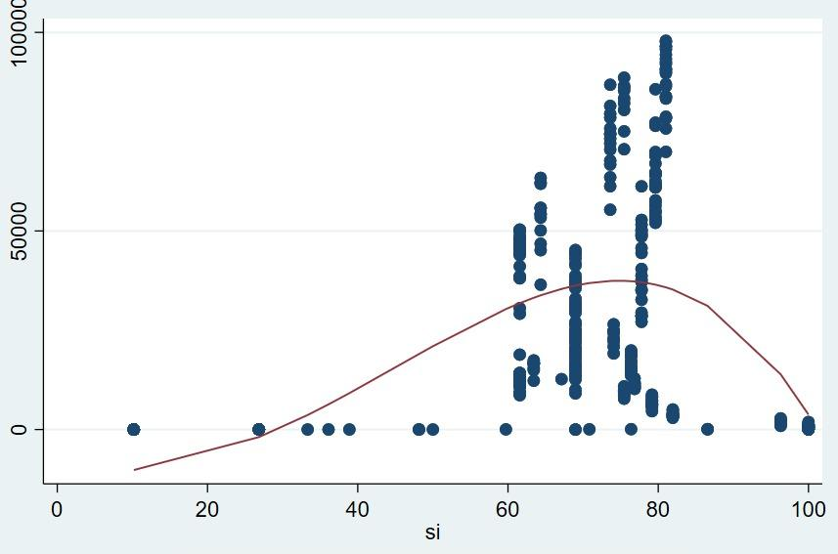

Figure 1. Non-parametric kernel regression function connecting cumulative cases with lockdown stringency

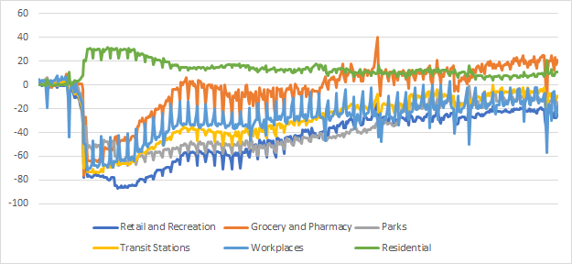

Figure 2. Mobility over a period of time with lockdown policy

We observed that in Indian cities air quality increased as the PM2.5 and PM10 levels started declining in a significant amount in the lockdown timeframe i.e. from March 2020 and this continued until November 2020.As the festival of Diwali occurred in November, PM2.5 and PM10 levels started to rise as firecrackers were burnt all over India and these fire related emissions were the cause of spike in PM2.5 and PM10 and air quality started decreasing from this point.

However in the case of Chandigarh this increase in PM2.5 and PM10 started mid-September due to crop harvesting due to exposure of ammonia , hydrogen sulphide , toxic organic compounds ,pesticides and particulate matter.

Delhi had the worst case among all the cities as its AQI went over 400 and touched even 450 which is very harmful for humans.

Patna had an average of 150 PM2.5 during March to October and its PM10 graph showed the similar trend as PM2.5.

Mumbai had an average of 100 PM2.5 during mid-April to mid-October and even 150 PM2.5 for the year 2020 and its PM10 graph also showed almost similar trend as PM2.5 .

Nagpur had an average PM2.5 even less than 150 during March to October however after that it kept on increasing as other cities.

Kolkata had an average PM2.5 much less than 150 during March to October and even in this period it went very close to 50 that was really a good sign for the atmosphere. But after that (November) it wasn't even under 200.

Banglore had an average PM2.5 of 150 during mid-March to October but surprisingly it was the same even in the month of November and increased after that. Its PM 10 also showed a similar trend as of PM2.5 .

Hyderabad also had an averaged PM2.5 much less than 150 during March to October and after that it never came near to 150. Its PM10 graph also showed a similar trend as of PM2.5

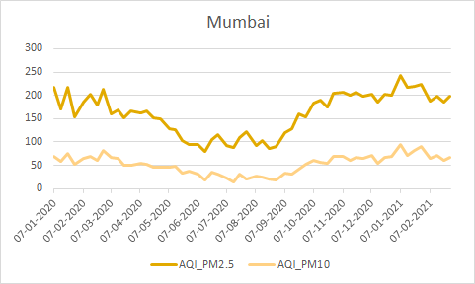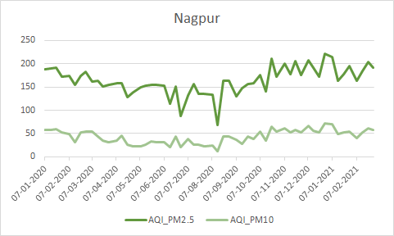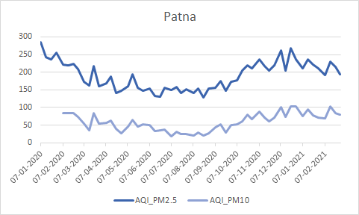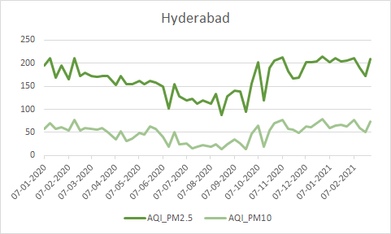 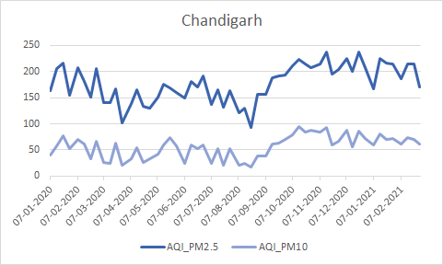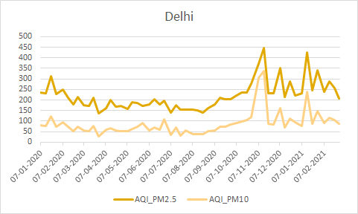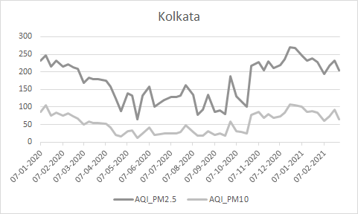 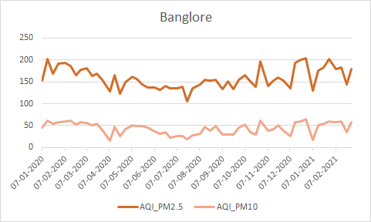

Figure 3. AQI due to PM 2.5 and PM 10 pollutants over the period of time with lockdown policy interventions

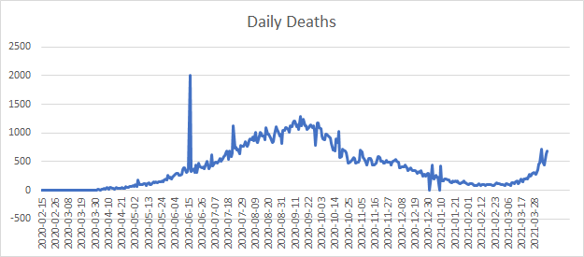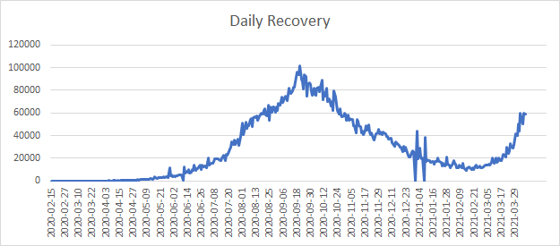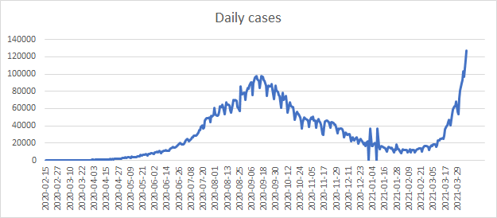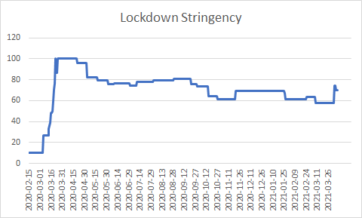

Figure 4:Top Left plot shows total no of daily cases with timeline ranging from 15-02-2020 to 29-03-2021.

Top Right plot shows total no of people .The ecovered daily with timeline ranging from 15-02-2020 to 29-03-2021.

Bottom Left plot shows total no of deaths daily with a timeline ranging from 15-02-2020 to 29-03-2021.

Bottom Right plot shows Lockdown Stringency with a timeline ranging from 15-02-2020 to 29-03-2021.

# LITERATURE REVIEW

There are several studies that analyze the impact of various factors and policies on air quality and pollution levels in particular regions or countries. Jasleen Kaur Sethi and Mamta Mittal analyze the Impact of Air Quality on the COVID-19 Fatalities in Delhi by using machine learning techniques.They first monitored the effect of lockdown on the various air pollutants due to the coronavirus disease (COVID-19) pandemic by comparing the monthly averages of AQI and the pollutants, namely, PM2.5, CO, NO2, SO2, ozone, PM10, toluene, benzene, and NH3, in January, February, and March 2020, with the averages of the previous 2 years.Then feature selection has been carried out using various machine learning techniques, namely, Decision Trees, Linear Regression, and Random Forest to know which pollutants may impact the mortalities due to COVID-19.

Based on the experimental work, it has been observed that the pollutants ozone and toluene have increased during the lockdown period. It has also been deduced that the pollutants that may impact the mortalities due to COVID-19 are ozone, NH3, NO2, and PM10. The study concludes with the suggestion that there is a need to impose measures to control ozone pollution, as there has been a significant increase in its concentration and it also impacts the COVID-19 mortality rate.

Another study by Malki,Zohair et al.(2020) examined the impact of weather variables like temperature and humidity on the spread of covid by extracting the relationship between the number of confirmed cases and the weather variables using the OLS model. Then some Machine Learning Models are being used to predict the spread of the Coronavirus like Extreme Gradient Boosting (XGBoost), Light Gradient Boosting Machine (LightGBM), and CatBoost Regressor, Kernel Ridge, Support Vector Machine (SVM), K-Nearest Neighbors Regressor (KNN), Multi-level Perceptron (MLP), and Decision Tree. These models are implemented by using each country’s input variables which are a combination of weather features (Humidity, Wind speed, Temperature, Sunny Hours), population variables (Population, Density, Fertility, Age, Urban percentage), and health center resources related variables (ICU) to predict the number of infections and death rates and knowing the relevance of these features in prediction.

The study concluded that the weather variables are more relevant in predicting the mortality rate when compared to the other variables such as population, age, and urbanization. Also, it is observed that the number of infection cases decreases as the temperature rises.

The impact of odd-even transportation policy and other factors on pollution in Delhi was studied by Mathur et al.(2019) using panel data. Firstly, spatial data analysis is used to understand climatic factors’ impact only on pollution levels existing in different locations in Delhi. Secondly, the RDD exercise is performed with an extended model on panel data of concentration of pollutants to know whether the odd-even transportation policy has reduced pollution in Delhi both in the short & long run and its impact on pollution levels existing in Delhi. In the RDD model, panel data of 5 pollutants during the period, 2015-18 ( using daily data) is used as dependent variables and Odd-even policy dummy, rainfall, wind speed, average temperature, relative humidity, time, Crackers ban dummy, daily petrol price, daily diesel price, highway dummy, agriculture residue burning, number registered public and private Vehicles and number of electric cars in Delhi are used as independent variables. Then the Durbin-Wu Hausman test is used to determine whether to use Fixed Effects or Random Effects on the model with polynomial terms and the other without polynomial terms, respectively.

The estimates of the RDD model suggest that the introduction of the odd-even scheme may not be responsible for increasing pollution levels in Delhi, at least in the long run. If the odd-even scheme needs to be successful, it has to be implemented for a longer time period with fewer exemptions. The paper concludes by providing some policy measures which should be undertaken for reducing pollution levels in Delhi.

Several other studies are also there which focus on the impact of covid on the economic condition of countries.

A study using an Input-Output (IO) model by Kanitkar(2020) aimed at estimating the economic losses and losses in the power sector in India due to COVID-19. The results from the model showed that depending on the duration of the lockdown, the Indian economy is likely to face a loss of about 10–31% of the estimated GDP for the year 2020-21. These estimates include both the direct losses in specific sectors because of the down times they face as well as indirect impacts on sectors because of their interdependence on other sectors of the economy. Also, the daily supply from coal-based thermal power plants has reduced by almost 26% during the lockdown resulting in reduced emissions of about 15–65 MtCO2.

RAA Putra(2020) explores the usefulness of different proxies like Google Mobility, Apple Mobility, and Night Time Light for measuring economic activity in 34 provinces in Indonesia. Her study establishes models to predict regional GDP based on mobility and considering the industry contribution to regional GDP. Furthermore, the estimated regional GDP is used to estimate the national GDP. Cluster analysis is used to classify regions based on their source of economic growth. K-Means clustering algorithm is used in the paper which aims to divide data into K clusters and then the within-cluster sum of squares is minimized. It is followed by a regression model which involves mobility change to predict GDP growth.

This study found that involving the industry contribution through clusters increases the explanatory power of mobility for regional GDP. It also provides a better fit model to estimate the regional GDP, which increases the accuracy of estimated national GDP. In addition, this study found that the industry contribution to regional GDP provides different effects on the relationship between mobility change and regional GDP growth. This study finds a consistently strong positive correlation between regional change on the average mobility report and the percentage changes of regional GDP in 34 provinces in Indonesia.

# METHODOLOGY

## OLS

Statistical method of Ordinary Least Squares (OLS) regression for analyzing the effect of cases, recoveries, deaths due to Covid and stringency index on Google Mobility Parameters which is a proxy we are using for tracking economic activity, as people's mobility is closely related to economic activities.

Box plot method can be used to check for the skewness of the dataset; logarithmic transformation can be applied for the rightly skewed data.

A general OLS regression model having n independent variables is written as:

Y = + +

where

–Y is the dependent variable,

– is the intercept of the model,

– corresponds to the jth independent variable,

– is the random error.

Given below are the detail of variables and equation used :

**Left-hand side:** (Google Community Mobility Parameter= { Retail & Recreation, Grocery & Pharmacy, Parks, Transit Stations, Workspaces, Residentials }

**Right-hand side**: Cumulative_Deaths, Cumulative_Recoveries, Cumulative_Cases, Lockdown_Stringency_Index

Through Visual inception, it is clear that data has heteroskedasticity, which goes against the assumption of OLS. So, to account for the heteroskedasticity robust OLS is applied. Logarithmic transformation is done to account for the right skewness.

**EQUATION:** *(Mobility_Parameter)*it+*log(Cumulative_Deaths)* +

*log(Cumulative_Recoveries)* + *log(Cumulative_Cases)* + 𝛽4 *Lockdown_Stringency_Index* + ε

## Panel Analysis

Panel data ( cross-sectional time-series data) of weather variables ( Temperature, humidity, wind Speed ) and Air Quality Index( AQI ) for pollutants ∈ { , } over eight Indian cities are analysed to find the relationship of AQI and weather variables during 14 months(Jan 2020 - Feb 2021). Further, the Lockdown dummy has been used to take into account the lockdown effect on the Air Quality Index.

Panel data allows control for variables that can’t be observed or measured as in our case different pollution control measures across industries or pollutant sources vary; factors affecting temperature across different cities etc.

In this paper, we focus on two techniques being applied to two models for panel data analysis:

### – Fixed effects

Fixed effects model controls for time-invariant unobserved individual characteristics that can be correlated with the observed independent variables.

The equation for the fixed effects model is:

Yit = β1Xit + αi + uit

Where

– αi (i=1….n) is entity-specific intercepts to capture heterogeneities across entities.

– Yit is the dependent variable where i = entity and t = time.

– Xit represents one independent variable (IV),

– β1 is the coefficient for that independent variable,

– uit is between-entity error

### – Random effects

Random effects model controls unobserved characteristics that are constant over time and which cannot be correlated with the observed independent variables.

The equation for the random effects model is:

Yit = β1Xit + α + uit + εit

Where

– Yit is the dependent variable where i = entity and t = time,

– Xit represents one independent variable (IV),

– β1 is the coefficient for that independent variable,

– uit and εit are between and within entity error respectively.

**Given below are the two models on which Random and Fixed effects techniques have been employed:**

## Model 1: Without polynomial terms

Below mentioned is the linear model specification on which panel analysis has been performed; the right-hand left-hand side variables are as follows:

**Left-hand side:** Air Quality Index for pollutants

**Right-hand side**: Windspeed, Temperature, Humidity, Lockdown dummy

**Durbin- Wu Hausman test**: To decide between fixed effect and random effect models.

= + +

## Model 2: With polynomial terms

Below mentioned is the non-linear model specification on which panel analysis has been performed; the right-hand left-hand side variables are as follows:

**Left-hand side:** Air Quality Index for pollutants

**Right-hand side**: Windspeed, Temperature, (Temperature, Humidity, Lockdown dummy

**Durbin- Wu Hausman test**: To decide between fixed effect and random effect models.

= + + +

# DATA DESCRIPTION

## Economic Activity

Our goal was to find the relation between the covid restrictions and the GDP. However, using quarterly GDP for our analysis was not possible due to lack of enough data. Hence, we resorted to Google’s Mobility index as an indicator of Economic activity. This mobility index consists of 6 variables showing the movement in 6 classes of places, i.e., Grocery and Pharmacy, Parks, Transit Stations, Retail and Recreation, Work Places, Residential. This movement is relative to a baseline. This baseline is the median value from the 5‑week period Jan 3 – Feb 6, 2020. This paper considers 4 variables with respect to each of these 6 mobility indexes, i.e. Stringency Index, cumulative Cases, cumulative Recoveries and cumulative Deaths. The following table shows the sources of these 4 variables along with a predicted hypothesis showing what kind of relation we expect these variables to depict.

**Table no 1. : Google Mobility Parameters**

|  |  |  |
| --- | --- | --- |
| No | Parameters  (Dependent Variable) | Description |
| 1 | Retail & recreation | Mobility trends for places like restaurants, cafes, shopping centers, theme parks, museums, libraries, and movie theatres |
| 2 | Grocery & Pharmacy | Mobility trends for places like grocery markets, food warehouses, farmers markets, specialty food shops, drug stores, and pharmacies |
| 3 | Parks | Mobility trends for places like local parks, national parks, public beaches, marinas, dog parks, plazas, and public gardens |
| 4 | Transit stations | Mobility trends for places like public transport hubs, such as subway, bus, and train stations |
| 5 | Workplaces | Mobility trends for places of work |
| 6 | Residential | Mobility trends for places of residence |

We have used Google’s Mobility Index data for each independent and dependent variables ranging from 15th Jan 2020 - 7th April 2021 in which the lockdown duration period is 21/ 03 /2020 - 31/05/2020.

So, we Have Cross-Sectional Data With Total Observations = 418

We used Robust OLS regression.

**Table no 2. : Variables, data description, data source**

|  |  |  |
| --- | --- | --- |
| **Variables** | **Description** | **Data Source** |
| Lockdown_Stringency_Index | Stringency Index due to covid in India | OxCGRT data oxford stringency index |
| Cumulative_Deaths | No. of total deaths due to covid in India | COVID-19 Data Repository by the Center for Systems Science and Engineering (CSSE) at Johns Hopkins University & Data from World Bank |
| Cumulative_Cases | No. of total covid cases in India |
| Cumulative_Recoveries | No. of total recoveries from covid in India |
| Google Mobility Parameters | Six parameters of Community Mobility Reports of Google | GOOGLE |

## 

## Air Quality

In this, we have tried to figure out the dependency of the Air Quality Index(AQI) on various factors such as Lockdown Stringency(SI), temperature, wind speed, and humidity.

So, Lockdown Stringency(SI), temperature, wind speed, and humidity are our independent variables

and Air Quality Index(AQI) is our dependent variable.

For our study, we have considered air pollutant p ∈ { PM2.5, PM10}

and 8 Indian Cities which are as follows :

1. Bengaluru
2. Chandigarh
3. Delhi
4. Hyderabad
5. Kolkata
6. Mumbai
7. Nagpur
8. Patna

We have used CENTRAL POLLUTION CONTROL BOARD (CPCB) data for each independent and dependent variables for each city over 4 particular days of a month (i.e. 07, 14, 21, and 28) ranging from Jan 2020 - Feb 2021 in which the lockdown duration period is 21/ 03 /2020 - 31/05/2020.

So,we Have Panel Data With Total Observations = 448

We used Fixed Effect, Random Effect, And Later used Hausman Test to decide between them.

**Table no 3. : Variables, data source, and data description**

|  |  |  |
| --- | --- | --- |
| **VARIABLES** | **Data Description** | **DATA SOURCE** |
| LOCKDOWN |  | DUMMY VARIABLE |
| TEMPERATURE | Average Daily Temperature of cities | CENTRAL POLLUTION CONTROL BOARD (CPCB) DATA |
| HUMIDITY | Average Relative Humidity of cities | CENTRAL POLLUTION CONTROL BOARD (CPCB) DATA |
| WINDSPEED | Average Wind Speed of cities | CENTRAL POLLUTION CONTROL BOARD (CPCB) DATA |
| POLLUTANTS CONCENTRATION | Daily Concentration of Pollutants like PM10 , and PM2.5 | CENTRAL POLLUTION CONTROL BOARD (CPCB) DATA |

AQI has been calculated using the concentration of pollutants PM10 and PM2.5 according to US EPA standards.

__________

# HYPOTHESIS

Covid-19 led to formulation of various policies implementing mobility and gathering restrictions; these steps were new to all, it was hard to predict or get to know the way people would respond. In this paper we are checking how people's reaction towards varying mobility restrictions during, pre and post pandemic period changed. Further we are also testing our hypothesis on Air quality variation with weather variables during , pre and post pandemic(Wave 1) period.

Higher lockdown stringency intends to restrict the movement of people outside their residence, therefore we hypothesise that due to increasing lockdown stringency we will get an increasing trend in Residential mobility and decreasing trend from the other five google community mobility parameters which are Retail and Recreation, Grocery and Pharmacy, Parks, Transit Stations and Workspaces.

People generally don't take things seriously until they get some proof of how dangerous the situation actually is. An alarmingly increasing number of deaths did the work of an eye-opener for everyone and hence people in order to protect themselves and their loved ones resented from going out of their houses and started taking precautions. Covid-19 forced the population of the second-largest democracy of the world to stay home. So, we hypothesise that deaths due to covid will have a positive trend with residential mobility and a negative trend with other google community mobility parameters.

Increasing covid recoveries imparts a sense of returning to normalcy and confidence of being immune to covid, amongst the population. Considering these two factors we hypothesise residential mobility to have a negative variation with cumulative recoveries, and all other five google community mobility to have a positive variation with cumulative recoveries.

For cumulative cases, we hypothesise a negative relation with residential mobility parameters and positive with all other parameters, which is self-explanatory, as more people come out of their houses, the greater is the risk and more people get infected which leads to rise in the number of cases.

**Table no 4. : Variables, data sources, and hypothesis**

|  |  |  |  |  |  |  |  |
| --- | --- | --- | --- | --- | --- | --- | --- |
| **Variables** | **Data Sources** | **Hypothesis** | | | | | |
| **Retail & Recreation** | **Grocery & Pharmacy** | **Parks** | **Transit stations** | **Work places** | **Residential** |
| Lockdown_Stringency_Index | OxCGRT data oxford stringency index | Negative | Negative | Negative | Negative | Negative | Positive |
| Cumulative_Deaths | COVID-19 Data Repository by the Center for Systems Science and Engineering (CSSE) at Johns Hopkins University & Data from World Bank | Negative | Negative | Negative | Negative | Negative | Positive |
| Cumulative_Recoveries | Positive | Positive | Positive | Positive | Positive | Negative |
| Cumulative_Cases | Positive | Positive | Positive | Positive | Positive | Negative |

Wind speed plays a vital role in atmosphere dilution, and high speed favors the dispersal of pollutants, clearing the air. Pollutants tend to pile up in calm conditions. Pollution levels due to vehicle emissions are likely to be higher on a low wind day. Hence, we hypothesise wind speed to vary negatively with the Air Quality Index thereby improving the air quality.

Temperature variation with air quality depends on multiple factors, due to which a strong hypothesis can't be made prior. Still considering that more number of months under our observation lies in winter, we hypothesise Temperature to have a positive relationship with the Air Quality Index.

High humidity increases the water content in the atmosphere, thereby increasing the concentration of pollutants; considering this, we hypothesise Humidity to vary positively with the Air Quality Index.

As stricter lockdown measures restrict more internal or international interactions and associated socio-economic activities that rely on such interactions, primarily affecting the manufacturing industry, leading to a dramatic decline in emissions. We hypothesise lockdown dummy to vary negatively with the Air Quality Index.

**Table no 5. : Variables, data source, and hypothesis**

|  |  |  |
| --- | --- | --- |
| **VARIABLES** | **DATA SOURCE** | **HYPOTHESIS** |
| LOCKDOWN | DUMMY VARIABLE | NEGATIVE IMPACT |
| TEMPERATURE | CENTRAL POLLUTION CONTROL BOARD (CPCB) DATA | POSITIVE IMPACT |
| HUMIDITY | CENTRAL POLLUTION CONTROL BOARD (CPCB) DATA | POSITIVE IMPACT |
| WINDSPEED | CENTRAL POLLUTION CONTROL BOARD (CPCB) DATA | NEGATIVE IMPACT |

# RESULTS

**Table no 6. : Panel data results of pollutants**

|  |  |  |  |  |  |  |  |  |
| --- | --- | --- | --- | --- | --- | --- | --- | --- |
| Variables | Model 1 | | | | Model 2 | | | |
| Fixed Effect | | Random Effect | | Fixed Effect | | Random Effect | |
| PM10 | PM2.5 | PM10 | PM2.5 | PM10 | PM2.5 | PM10 | PM2.5 |
| Lockdown Dummy | -10.13***  (3.717) | -17.75***  (5.366) | -10.18***  (3.705) | -17.88***  (5.349) | -7.21**  (3.466) | -13.10***  (4.913) | -7.31**  (3.459) | -13.26***  (4.904) |
| Humidity | -0.17**  (0.075) | -0.17  (0.109) | -0.17**  (0.075) | -0.17  (0.108) | -0.43***  (0.076) | -0.57***  (0.108) | -0.43***  (0.076) | -0.56***  (0.107) |
| Wind Speed | -21.52***  (3.556) | -40.57***  (5.153) | -20.78***  (3.504) | -39.31***  (5.073) | -24.63***  (3.321) | -44.93***  (4.717) | -23.96***  (3.286) | -43.90***  (4.668) |
| Temperature | -0.34  (0.222) | -1.16***  (0.324) | -0.36  (0.220) | -1.18***  (0.322) | 5.41***  (0.716) | 8.33***  (1.048) | 5.31***  (0.714) | 8.20***  (1.048) |
| Temperature Square | - | - | - | - | -0.15***  (0.018) | -0.25***  (0.026) | -0.15***  (0.018) | -0.24***  (0.026) |
| Constant | 96.50***  (5.303) | 254.25***  (8.024) | 95.97***  (8.196) | 253.48***  (12.884) | 72.89***  (5.670) | 211.15***  (8.620) | 72.59***  (9.784) | 201.75***  (14.237) |
| Observations | 441 | 441 | 441 | 441 | 441 | 441 | 441 | 441 |
| R-squared | 0.198 | 0.293 | - | - | 0.311 | 0.415 | - | - |
| Number of city_grp | 8 | 8 | 8 | 8 | 8 | 8 | 8 | 8 |

*** p<0.01, ** p<0.05, * p<0.1

The above results(Table no.6) are based on the panel analysis of cross-sectional time series data of weather variables and Air quality Index( for pollutants PM10 and PM2.5 ) done across eight Indian cities over the duration of fourteen months including the time of pandemic.

Weather factors such as temperature, humidity and wind speed were taken into consideration; we checked for the effect of lockdown on Air quality using a lockdown dummy. We observed that Lockdown significantly improved the Air quality by reducing AQI values for both PM10 and PM2.5 pollutants in all the cities; the same can directly be observed by simply looking at their graph plots. Wind Speed tends to have a negative and significant effect on air quality in both models.Temperature shows a negative and insignificant variation in Model 1 for pollutant PM10 whereas negative and significant for pollutant PM2.5. Temperature also shows significant downward parabolic relation with Air quality in Model 2 for both pollutants PM10 and PM2.5.

Robust OLS Regression

Applied on Google Community Mobility Parameters

|  |  |  |  |  |  |  |
| --- | --- | --- | --- | --- | --- | --- |
|  | (1) | (2) | (3) | (4) | (5) | (6) |
| VARIABLES | Retail & Recreation | Grocery & Pharmacy | Parks | Transit Stations | Work Places | Residentials |
|  |  |  |  |  |  |  |
| Cumulative_Cases | 42.45*** | -10.27*** | 53.24*** | 19.82*** | -7.60* | 1.63 |
|  | (2.466) | (3.110) | (3.225) | (1.916) | (4.059) | (1.433) |
| Cumulative_Deaths | -36.76*** | -4.21 | -25.36*** | -22.75*** | -18.86*** | 8.12*** |
|  | (2.918) | (4.010) | (2.958) | (2.304) | (3.505) | (1.256) |
| Cumulative_Recovery | -4.69 | 14.23*** | -23.15*** | 3.25 | 21.73*** | -7.94*** |
|  | (2.968) | (3.405) | (4.088) | (2.286) | (4.584) | (1.640) |
| Lockdown_Stringency_Index | -0.87*** | -1.01*** | -0.90*** | -0.91*** | -0.55*** | 0.26*** |
|  | (0.055) | (0.064) | (0.078) | (0.044) | (0.088) | (0.029) |
| Constant | -142.20*** | 64.63*** | -49.87*** | -55.30*** | 15.41 | -3.00 |
|  | (9.543) | (11.882) | (9.865) | (7.134) | (12.220) | (4.383) |
|  |  |  |  |  |  |  |
| Observations | 393 | 393 | 393 | 393 | 393 | 393 |
| R-squared | 0.935 | 0.881 | 0.753 | 0.925 | 0.694 | 0.824 |

Robust standard errors in parentheses

*** p<0.01, ** p<0.05, * p<0.1

**Table no 7. : OLS Model Results**

The table no.7 shows the estimation by robust OLS model using data of google community mobility parameters and other independent variables for India over a time period of around 14 months(starting from February 2020).

The coefficients indicate that an increase in cases led to increased mobility of Retail & Recreation, Parks, transit stations, and residentials, and decreased mobility of grocery & Pharmacy and workplaces. On the other hand, cumulative recoveries tend to have a negative and significant impact on Parks and Residentials' mobility while a positive significant impact on the mobility of Grocery & Pharmacy and Workplaces. cumulative Recoveries do not significantly impact the mobility of Retail & Recreation and Transit Stations.

Lockdown Stringency tends to have a negative and significant impact on all the mobility parameters except residential mobility.

Cumulative deaths seem to have a negative and significant impact on Retail & Recreation, Transit Stations, Parks and WorkPlaces and a positive significant impact on Residentials. It do not do not significantly impact the mobility of Grocery & Pharmacy

# CONCLUSION

The results from the OLS model show the people’s attitude and self-defensive actions towards the covid situation currently prevailing in the country. It also helped us to comment on the impact of covid on economic activities in India.

It seems that the alarmingly increasing number of deaths did the work of an eye-opener for everyone. Hence, people to protect themselves and their close ones resented from going out of their houses and started taking precautions. Covid 19 forced the population of the second-largest democracy of the world to stay at home.

It is evident from our results that people took recoveries way too positively. Increasing covid recoveries imparts a sense of returning to normalcy and confidence of being immune to covid amongst the population. So, they became negligent and overconfident and started coming out of their houses for essentials and work, and hence normal day-to-day activities were resumed.

This resulted in a continuous increase in the number of cases as people didn’t avoid traveling for recreation.

With increasing cases, we observed a negative relation with grocery and pharmacy mobility parameters. One potential reason could be that people started adopting some alternative methods to get groceries, maybe Online shopping. We are assuming that usage of pharmaceutical products would remain constant as they are a necessity .

Covid has a drastic effect on the economic condition of India. The government has introduced a lockdown to control the covid situation, but it has an adverse impact on the economy. As the stringency increases, residential mobility shows an increasing trend as people tend to remain in residential areas. The other five mobility parameters show a decreasing trend, showing a decrease in economic activity.

Thus, we conclude that the nationwide lockdown in India has led to a decrease in economic activities, hence crippled the country’s economy.

Rising pollution levels have always been a concern for the Indian government. Air pollution or environmental externalities are generated by production and consumption activities.

The study has shown that lockdown has a positive impact on the air quality of all the eight cities that we have considered. We have observed negative relation of stringency index with pollutants

(PM10 , PM 2.5) using both models . Also, all the climatic factors have significantly impacted the pollution in these cities

Thus we conclude that the counter-virus measures, particularly lockdown, cause enormous costs in terms of socio-economic factors on the one hand; on the other, they are socially beneficial in terms of improved air or environmental quality.

# REFERENCES

Sethi JK, Mittal M. Monitoring the Impact of Air Quality on the COVID-19 Fatalities in Delhi, India: Using Machine Learning Techniques [published online ahead of print, 2020 Oct 12]. *Disaster Med Public Health Prep*. 2020;1-8. doi:10.1017/dmp.2020.372

[<https://www.ncbi.nlm.nih.gov/pmc/articles/PMC7711355/>]

Malki Z, Atlam ES, Hassanien AE, Dagnew G, Elhosseini MA, Gad I. Association between weather data and COVID-19 pandemic predicting mortality rate: Machine learning approaches. *Chaos Solitons Fractals*. 2020;138:110137. doi:10.1016/j.chaos.2020.110137

[<https://www.ncbi.nlm.nih.gov/pmc/articles/PMC7367008/>]

Mathur et al. (2019), “The impact of odd-even transportation policy and other factors on pollution in Delhi: A spatial and RDD analysis,” ARTNeT Working Paper Series, No. 182, March 2019, Bangkok, ESCAP

[<https://www.unescap.org/sites/default/files/ARTNeT%20Working%20Paper%20No%20182.pdf>]

Tejal Kanitkar,The COVID-19 lockdown in India: Impacts on the economy and the power sector,

Global Transitions,Volume 2,2020,Pages 150-156,ISSN 2589-7918,

[<https://www.sciencedirect.com/science/article/pii/S2589791820300153>]

Google. (2020). Google Community Mobility Reports.

[<https://www.google.com/covid19/mobility/>]

# APPENDIX

## Box Plot

Figure 5 Top Left plot shows box plot of lockdown stringency ,Top Right plot shows box plot of Cumulative cases,Bottom Left plot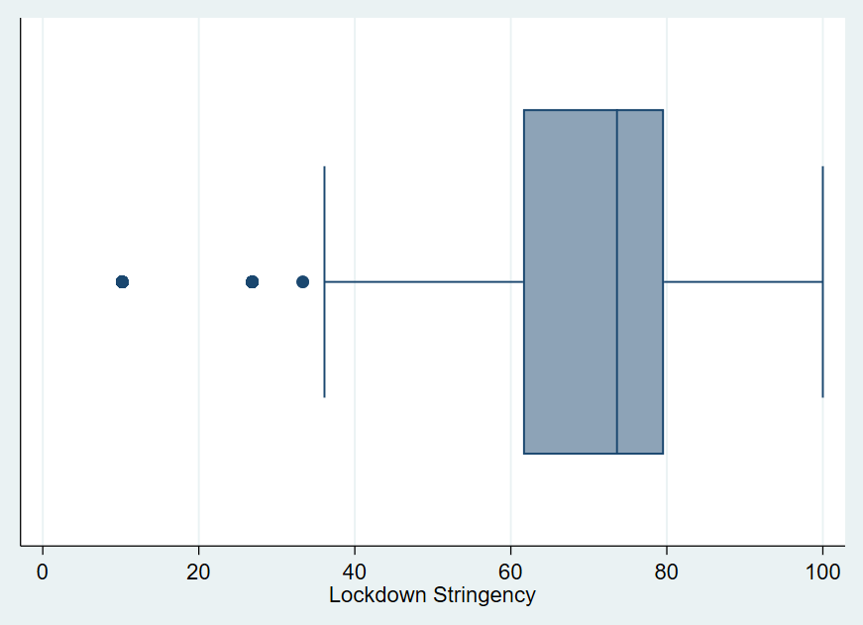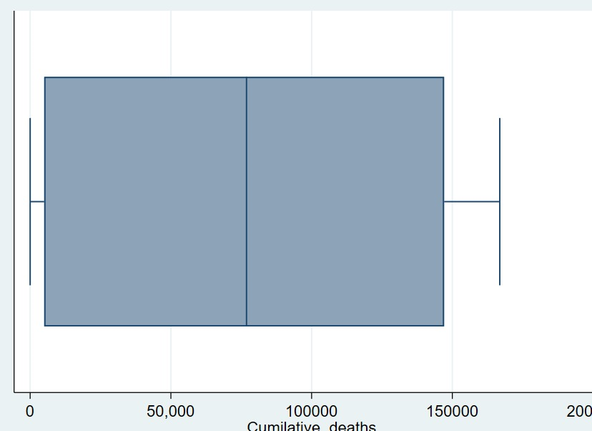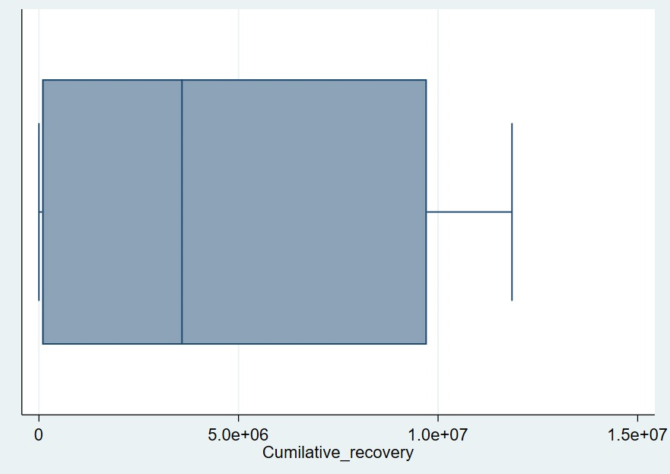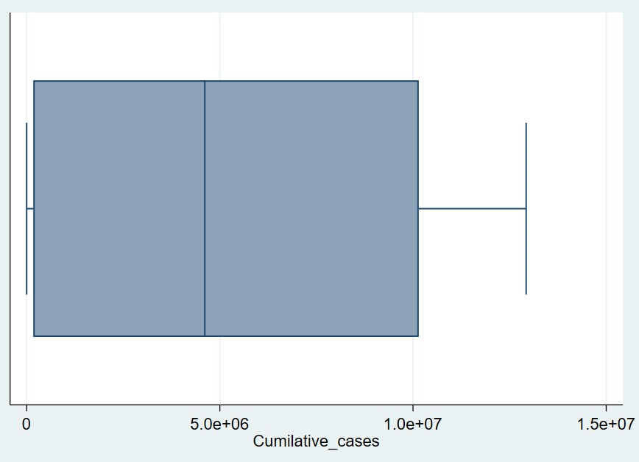

shows box plot of Cumulative deaths,Bottom Right plot shows box plot of Cumulative recovery

